# LM35 Temperature Sensor

The LM35 is a precision temperature sensor that provides an analog output voltage proportional to the temperature in Celsius.

**Working Principle:**  
The sensor outputs 10 mV per °C rise in temperature. For example, 250 mV corresponds to 25°C. It does not require any external calibration.

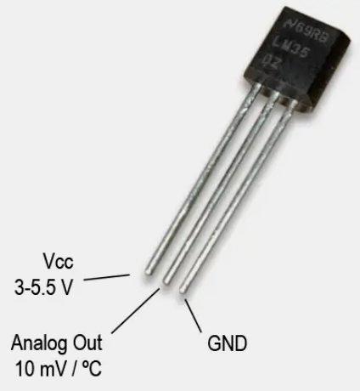**Types**:  
- LM35DZ (TO-92 package)  
- LM35DT (TO-220 package)

**Applications**:   
- Environmental monitoring  
- Industrial control  
- Weather stations  
- Arduino projects

**Advantages**:  
- High accuracy  
- Linear output  
- Easy to interface with ADCs

**Disadvantages**:  
- Analog output can be noisy  
- Sensitive to long wires without shielding Fig: LM35 Sensor